IT2120 - Probability and Statistics
Lab Sheet 10

Exercise

1)

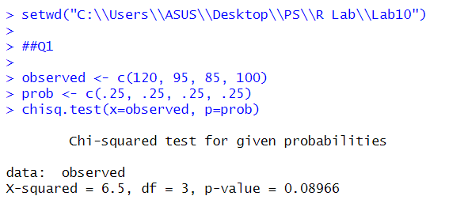

2)
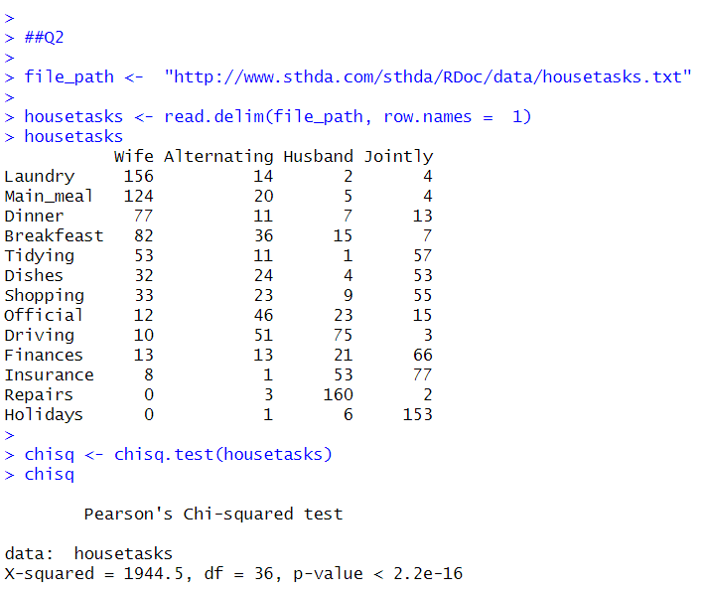

3)
